**Module 4 Lesson 3:**

**Rules of Exponents**

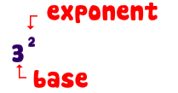

**Learning Target:**

* **I can use the rules of exponents to simplify expressions involving positive, negative, zero, and rational exponents.**

**Rules of Exponents:**

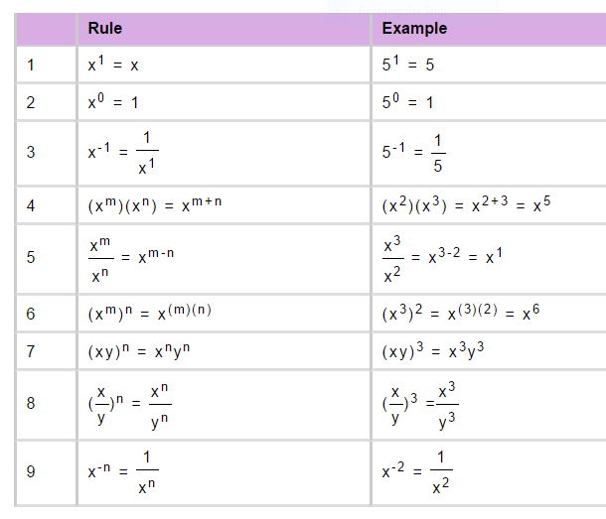

**Fractional Exponents:**

**Rule: $a^{p/r}$ is the same as $\sqrt[r]{a^{p}}$ or ${(\sqrt[r]{a} )}^{p}$**

**Simplify each of the following using the rules of exponents:**

**Ex. ${(2a^{4}c^{7})}^{3}$ Ex. ${(-5xy^{3})}^{4}$**

**Ex. ${(4p^{2}q^{3})}^{2}{(-3p^{5}q^{2})}^{3}$ Ex. $\frac{24{ a}^{7}{ b}^{10}c^{2}}{18 a b^{10}{ c}^{5}}$**

**Ex. ${(8x^{12}w^{3})}^{\frac{2}{3}}$ Ex. ${(16a^{3}b^{6})}^{\frac{3}{4}}$**

**Ex. Compute: ${16}^{3/2} + {10}^{0}- {27}^{2/3}$**

**Now let’s take a look at negative exponents………**



**Simplify the following and express the final answer without using any negative exponents.**

**Ex. ${(4x^{-2}y^{3})}^{-1}$ Ex. $\frac{14{ a}^{-3}{ b}^{4} c^{-8}}{-21{ a}^{5} b^{-1}{ c}^{-6}}$**

**Ex. ${(-8w^{-21}y^{24})}^{-\frac{2}{3}}$ Ex. $(4f^{-2}g^{3})(-f^{3}g^{-4})³$**

**Ex. ${(\frac{-2u^{-4}v^{5}}{3u^{7}v^{2}} )}^{-3}$ Ex. ${(-\frac{15x^{5}y^{-1}z^{2}}{25x^{0}y^{3}z^{-2}} )}^{-2}$**

**Ex. ${(4p^{-3}r^{5})}^{-2}$ Ex. ${(-3x^{7}y^{-1})}^{-4}$**

**Ex. $\frac{{\left(-2x\right)}^{-2}(y^{-5})}{{(3x^{3})}^{-3}}$ Ex. $\frac{18a^{-2}c^{8}d^{-3}}{30a^{5}c^{-1}d^{-6}}$**