**Module 3 Lesson #6:**

**13.7 Phase Shifts**

**Translating Sine and**

**Cosine Functions**

**All functions in the sine and cosine family of functions can be completely described by their amplitude, period, vertical shift, and horizontal shift (phase shift).**

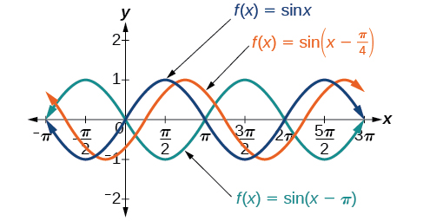

Recall the parent function y = x2

How is the graph of y = x2 + 5 moved?

How is the graph of y = (x – 4)2 + 5 moved?

We will use these same rules when shifting trig graphs. Today we will explore sine and cosine graphs and how they SHIFT!

Transformed functions are of the form:

Still Midline: how far up or down graph moves

$$y=a sin (bx-c)+d$$

OR

Still: Amplitude

If Negative: vertical flip

$$y=a cos \left(bx-c\right)+d$$

b is still: frequency

c: movement of graph left or right…however, it’s “–c/b”

PHASE SHIFT FORMULA (MEMORIZE):

$$\frac{-c}{b}$$

Phase shifts and vertical translations do NOT change the period or amplitude of trig functions.

**Example 1:**

**Graph ONE cycle of: $y=\cos\left(3x-π\right)+7$**

**Example 2:**

**Graph ONE cycle of: $y=-5\sin\left(2x+\frac{π}{2} \right)+1$**

**Example 3:**

**Graph ONE cycle of: $y=-4\sin{(3x-\frac{π}{4})}$**

**Example 4:**

**Graph ONE cycle of: $y=-sin⁡(\frac{x}{2}+\frac{π}{4} )$**

PRACTICE TIME! - HOMEWORK

1. Graph ONE cycle of

2. Graph ONE cycle of:

3. Graph ONE cycle of:

4. Graph ONE cycle of:

5. Graph ONE cycle of:

6. Graph ONE cycle of: $y=4\cos\left(\frac{x}{3}-\frac{π}{2}\right)+10$

Multiple Choice Practice

1. What is the phase shift of the function $f\left(x\right)=7\sin\left(2x-\frac{π}{3}\right)?$
   1. $\frac{π}{3}$ b. $\frac{π}{6}$ c. $-\frac{π}{3}$ d. $\frac{-π}{6}$
2. What is the range of the function $f\left(x\right)=-6\cos\left(πx-\frac{π}{2}\right)+2$?
   1. [-6,6] b. [-4,8] c. [0,8] d. [-6,0]
3. State the amplitude, period, and phase shift of the function
 $$h\left(t\right)=-2sin\left(3t+\frac{π}{6}\right)$$

  1. Amplitude: -2 Period: $\frac{2π}{3}$ Phase Shift: $\frac{-π}{18}$
   2. Amplitude: -2 Period: $\frac{2π}{3}$ Phase Shift: $\frac{-π}{2}$
   3. Amplitude: 2 Period: $\frac{2π}{3}$ Phase Shift: $\frac{-π}{2}$
   4. Amplitude: 2 Period: $\frac{2π}{3}$ Phase Shift: $\frac{-π}{18}$
4. What is the maximum value that the graph of $f\left(x\right)=23-13sin⁡(2x-π)$ will reach?
   1. 23 b. 13 c. 36 d. 10