**Module 4 Lesson 9: Exponential Equations**

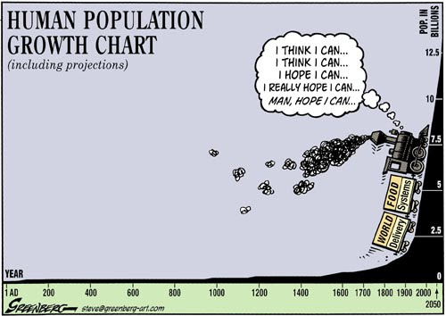

**Learning Targets:**

* I can solve exponential equations by using logarithms.
* I can use logarithms to solve real world problems.
* I can determine the values of $a$, $b$, and $c$ in the heating/cooling formula.

**Solving an Exponential Equation – Common Base**

${16}^{3x}=8$

**Solving an Exponential Equation – Can’t Get Common Bases**

$5^{x}=18$

2. $2^{x}-4=1556$ 5) $4{(2)}^{x}-3=17$
3. $6^{x+3}=50$ 6) ${\left(\frac{1}{2}\right)}^{\frac{x}{3}+1}=\frac{1}{6}$
4. $17{(5)}^{\frac{x}{3}}=4$ 7) $\log_{7}21=x$

**Solving Exponential Equations with $e$**

In each of the following, find the value of $x$ to the nearest thousandth.

1. $4e^{2x}+2=16$ 3. $2e^{-x}=20$

$7-2e^{\frac{x}{2}}=1$

**Applications**

1) Which of the exponential functions below show **growth** and which show **decay**? For each example, identify the rate of growth/decay.

a)  b)  c) 

d)  e)  f) 

2) Since January 1980, the population of the city of Brownville has grown according to the mathematical model, where *x* is the number of years since January 1980.

a) Explain what the numbers 720,500 and 1.022 represent in this model.

b) What would the population be in 2000 if the growth continues at the same rate.

c) Use this model to predict about when the population of Brownville will first reach 1,000,000.

3) The half-life of a medication is the amount of time for half of the drug to be eliminated from the body. The half-life of *Advil* or ibuprofen is represented by the equation, where *R* is the amount of Advil remaining in the body, *M* is the initial dosage, and *t* is time in hours.

a) A 200 milligram dosage of Advil is taken at 1:00 pm. How many milligrams of the medication will remain in the body at 6:00 pm?

b) If the doctor says a person can take another 200 milligram dosage of Advil when 10 milligrams or less is remaining, how long (to the nearest tenth), must a person wait to take the next dosage?