**Module 2 Lesson #8: Solving Radical Functions (section 6.5)**

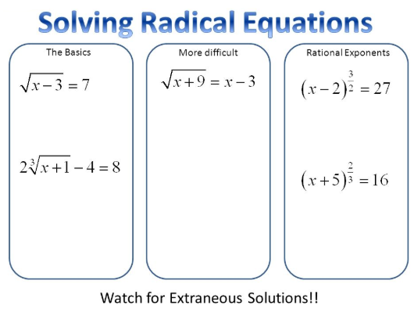

Learning Targets:

I can….

* Solve a square root equation.
* Identify extraneous roots.
* Solve radical equations with rational exponents by raising each side to the reciprocal power

**Solving Radical Equations**

Example 1: What is the solution of $3+\sqrt{2x-3}=8$? Check your answer.

Example 2: What is the solution of $3{(x+1)}^{\frac{2}{3}}=12$?

THINK

*How can you get rid of a rational exponent?*

Example 3: What is the solution of $3\sqrt[5]{{(x+1)}^{3}}+1=25$?

Example 4: Find all the solutions to $\sqrt{x^{2}-8x}=3$.

Example 5: What is the solution of $\sqrt{x+7}-5=x$? Check your answer graphically.

Example 6: What is the solution of $\sqrt{2x+1}-\sqrt{x}=1$

Application: For Meteor Crater in Arizona, the formula $d=2\sqrt[3]{\frac{V}{0.3}}$ relates the diameter $d$ of the rim (in meters) to the volume $V$ (in cubic meters). What is the volume of Meteor Crater if its diameter is $1.2 km$?

HOMEWORK: Extra Examples:

Find the solution to each of the following problems:

1. $\sqrt{5x-1}+3=x$ 3. $2{(x+3)}^{\frac{2}{3}}=8$

$\sqrt{5x+4}-\sqrt{x}=4$