**Module 4 Lesson 2**

**Arithmetic 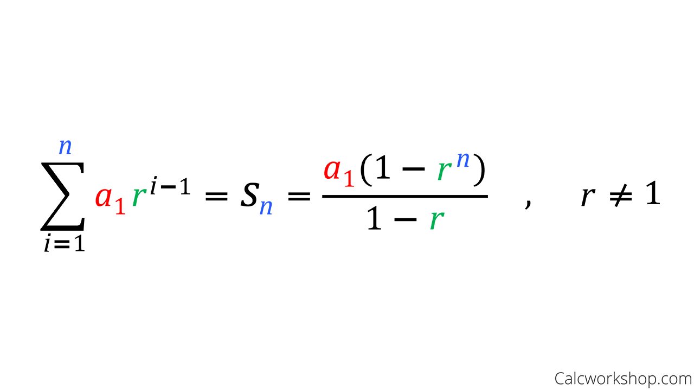&Geometric Series**

Learning Targets:

I can describe the difference between a sequence and a series.

I can find the sum of a finite arithmetic and geometric series two different ways.

I can write a rule to find the sum of n terms of an arithmetic or geometric sequence.

I can extend my knowledge of arithmetic and geometric series to real world situations.

A ***series*** is

* A ***finite*** sequence has a first and last term so the sum can be found.
* An ***infinite*** sequence continues without end so the sum cannot be found.

**The SUM of a Finite Arithmetic or Geometric Series**

Formula: The sum $S_{n}$ of a finite arithmetic series $a_{1}+a_{2}+a_{3}+ . . . + a_{n}$ where $a_{1}$ is the first term, $a_{n}$ is the nth term, and $n$ is the number of terms is

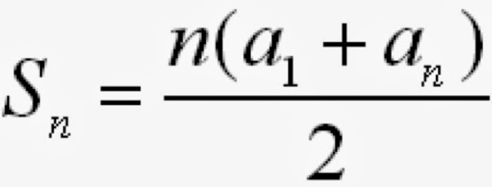

Formula: The sum $S_{n}$ of a finite geometric series $a_{1}+a_{2}+a_{3}+ . . . + a_{n}$ where $a_{1}$ is the first term, $a_{n}$ is the nth term, and $n$ is the number of terms is

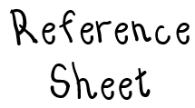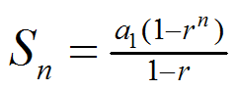

But the sum can also be found on the calculator by

**Sigma Notation $Σ$**

You can use the Greek letter sigma $Σ$ to indicate a sum. Use limits to tell you how many terms are being added.

**Example 1:** Express the sum of the arithmetic sequence below using $Σ$ notation.

$$5 + 8 + 11 + 14 + 17 + 20$$

**Example 2:** Find the sum of the first 25 terms in the sequence $5, 9, 13, 17, ….$

**Example 3:** Find the sum of the first eight terms of a sequence whose first term is $3$ and whose common ratio is $4$.

**Example 4:** Write the series shown below in summation form. Then find the value of the series.

$$6+12+24+…+768$$

**Example 5:** There are 30 rows of seats in an arena. The first row has 10 seats and each row increases by 3 seats.

1. How many seats are in the last row?
2. How many seats are there in all?

**Example 6:** A person places 1 penny in a piggy bank on the first day of the month, 2 pennies on the second day, 4 pennies on the third day, and so on. Will this person be a millionaire at the end of the 31 day month? Justify your answer.

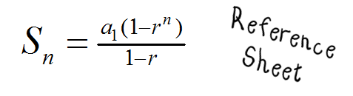**Let’s see some examples of Regents questions around the Geometric Series…**

