**Module 5 Lesson 6:**

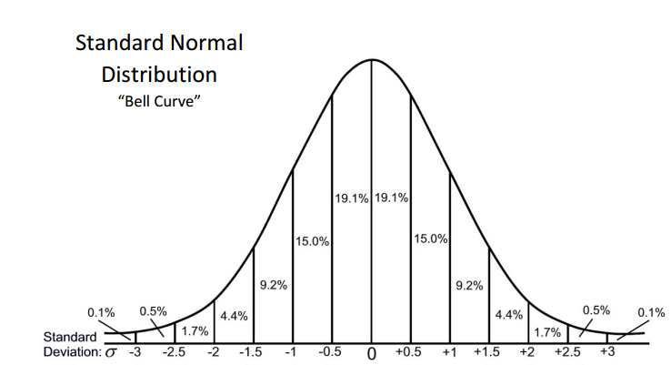**Normal Distributions**

Learning Targets

I can…

Describe the characteristics of a normal curve and use areas under a normal curve to estimate the proportion of the data values that fall within a given interval.

Calculate probabilities associated with normal distributions.

Use the Empirical Rule on Normal Distributions.

Calculate the percentile for a given data point.

If asked to find percentage...

Steps on the Calculator:

**Exercise 1:** At Arlington High School, 424 juniors recently took the SAT exam. On the math portion of the exam, the mean score was 540 with a standard deviation of 80. If the scores on the exam were normally distributed, answer the following questions.

(a) What percent of the math scores fell between (b) How many scores fell between 500 and 660?

500 and 660? Round your answer to the nearest whole

number.

(c) If Evin scored a 740 on his math exam, what (d) Approximately how many students scored at

is his percentile rank? the same or better than Evin? Round to the

nearest student.

Percentile-

Exercise 2: The heights of 16 year old teenage boys are normally distributed with a mean of 66 inches and a standard deviation of 3. If Jabari is 72 inches tall, which of the following is the closest to his height’s percentile rank?

1. 85th (3) 67th

1. 98th (4) 93rd

Exercise 3: The weights of Siamese cats are normally distributed with a mean of 6.4 pounds and a standard deviation of 0.8 pounds. If a breeder of Siamese cats has 128 in his care, how many can he expect to have weights between 5.2 and 7.6 pounds?

1. 106 (3) 98
2. 49 (4) 111

Exercise 4: If one quart bottles of apple juice have weights that are normally distributed with a mean of 64 ounces and a standard deviation of 3 ounces, what percent of bottles would be expected to have less than 58 ounces?

1. 6.7% (3) 0.6%
2. 15% (4) 2.3%

Exercise 5: A normal distribution of values has a mean of 47 and a standard deviation of 3.2.

1. Find the percentage of values

that lie between 42 and 50.

1. Find the percentage of values

that are greater than 50.

1. Find the percentage of values

that are less than 42.

Normal Distribution

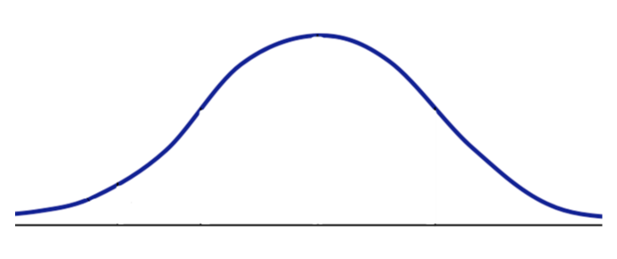

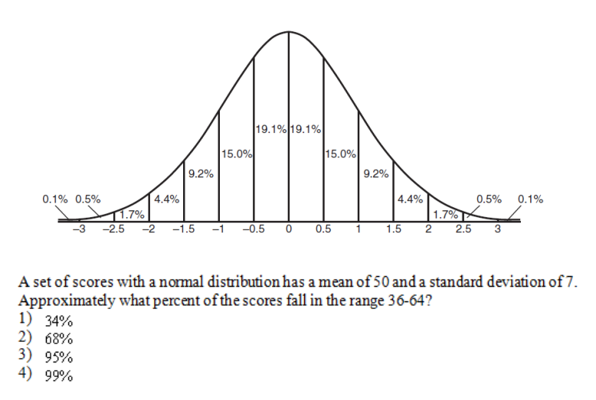

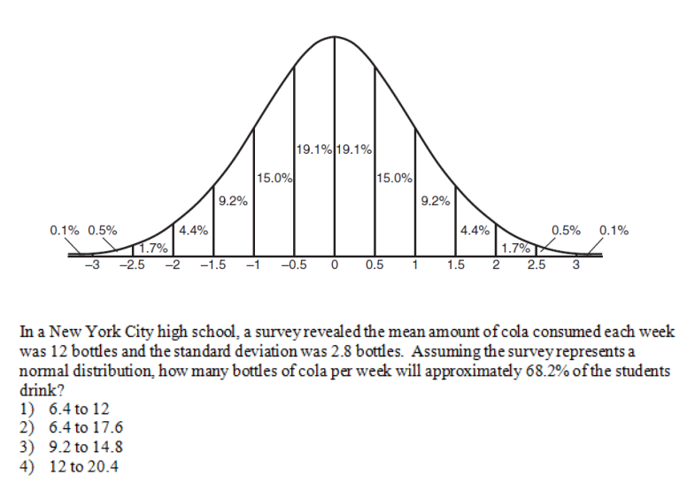

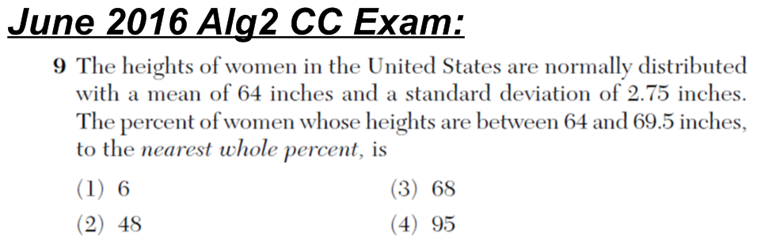

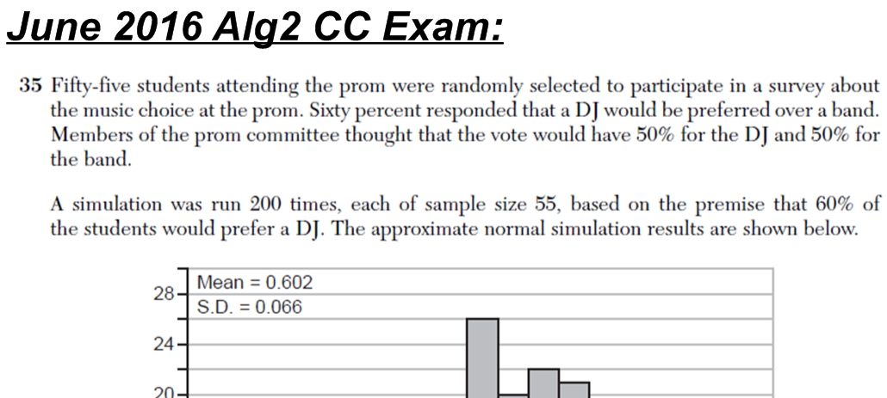

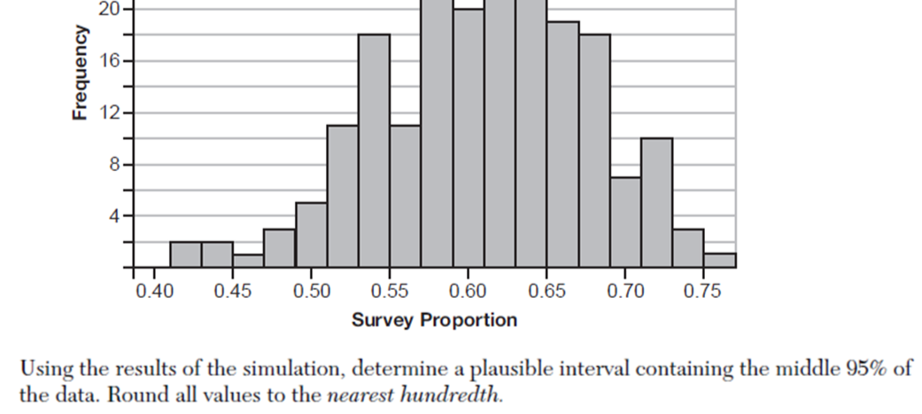



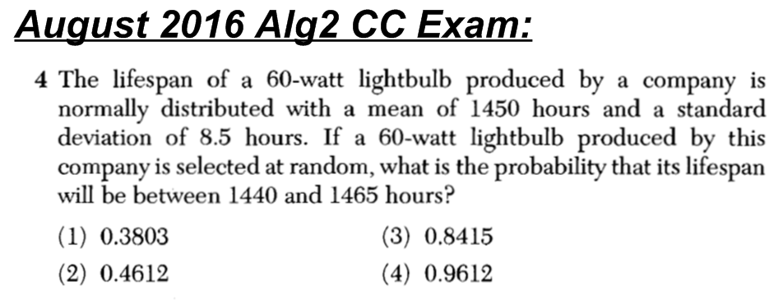

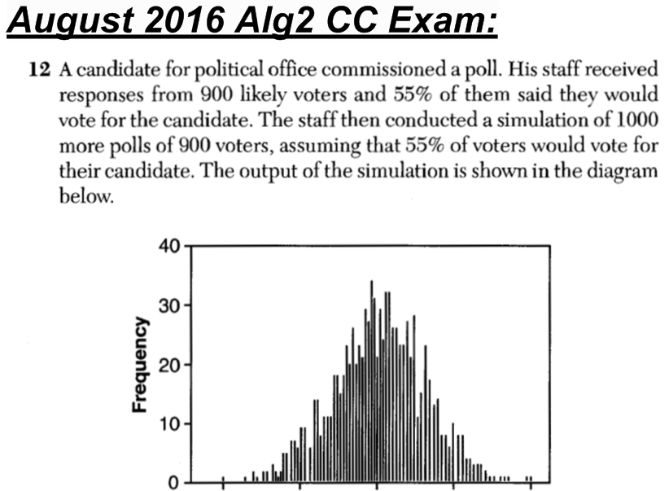

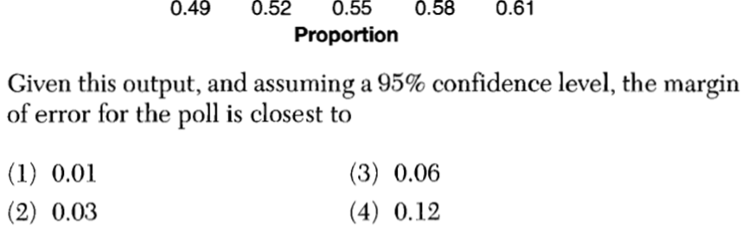

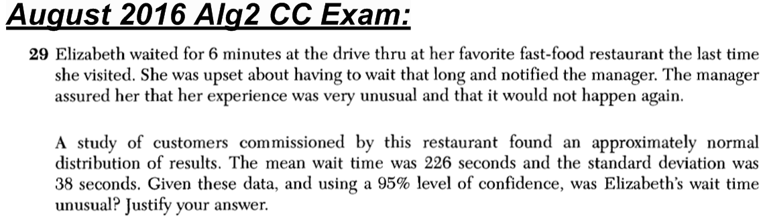

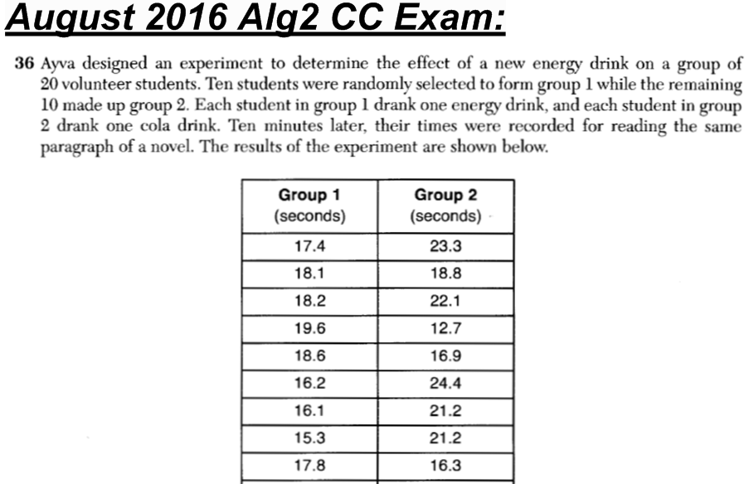

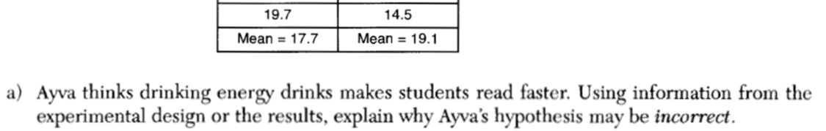

(CONTINUED ON NEXT PAGE…)

