**Module 3 Lesson 7: The Tangent Function**

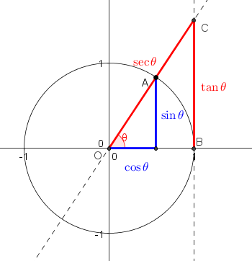

**Learning Targets**

I can recognize the relationship between sine, cosine and tangent on the unit circle and use this to find the values of the tangent of various angles.

I can draw one cycle of the parent tangent function, $y=tan x,$ and know it has a period of $π$ and amplitude of 1.

I can draw one cycle of a transformed tangent function $y=a tan bx,$ and identify the period as $\frac{π}{b}$ and state the equations of the asymptotes. I can recognize when the graph is reflected over the x-axis and understand why.

I can determine the number of cycles that will occur in $π$ radians.

**Before we graph the Tangent Function …**

**Let’s review Trigonometric**

**Functions on a unit circle.**

Given the point $\left(x, y\right)$ on the unit circle:

$$tan θ=$$

Find the following

$\tan{π}$ $\tan\left(-\frac{π}{4}\right)$

$\tan{150°}$ $\tan{\frac{3π}{2}}$

**Graphing the Tangent Function**

|  |  |  |  |  |  |
| --- | --- | --- | --- | --- | --- |
|  | 0o | 90o | 180o | 270o | 360o |
|  |  |  |  |  |  |

Sketch the graph of $y=tanx$ in the interval $\left[0, 2π\right]$

$$y=atanbx$$

$a=$

***frequency =***

$$period =$$

$$asymptotes$$

***Example 1:*** Graph one cycle of $y=2tanx$ in the interval $\left[-\frac{π}{2}, \frac{π}{2}\right]$

Write the equations of the asymptotes.

***Example 2:*** Graph one cycle of $y=-tanx$

***Example 3:*** Graph one cycle of $y=2tan\frac{θ}{4}$

***Example 4:*** Identify the period and where two asymptotes occur for the following.

$y=2tan3x$

$y= -tan\frac{3θ}{2}$