**Module 4 Lesson 7: Log & LN Function**

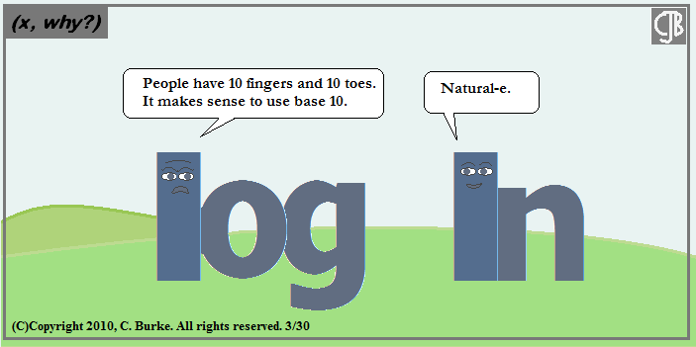

**Learning Targets**

I can draw the graphs of the exponential function and logarithmic function and describe the connection between them.

I can write the domain and range for both a log function and the exponential function and understand the relation between the two functions.

I can convert between $y=b^{x}$ and $\log_{b}y=x$ and understand the restrictions on the bases and domains.

I can find the equation of the inverse of a logarithmic function.

**Writing an Exponential Equation in Logarithmic form.**

**Logarithmic Form**

**Exponential Form**

For $b>0, b≠1, \log_{b}x=y if and only if b^{y}=x$

Examples:

1. If $f\left(x\right)=5^{x}$, write the equation for $f^{-1}(x)$

(remember: inverse…switch x & y and solve for y)

1. If $f\left(x\right)={10}^{x}$, write the equation for $f^{-1}(x)$

**Evaluating a Logarithm**

Example Steps

$\log_{8}{32=x}$

$$\log_{3}{x=4}$$

Solve for x. Round answers to the nearest tenth if needed.

1.  2.  3.  4. 

5. 6. 7. 8.

Memorize

These!

|  |  |
| --- | --- |
| Exponent Properties | Logarithmic Properties |
| $$b^{m}b^{n}=b^{m+n}$$ |  |
| $$\frac{b^{m}}{b^{n}}=b^{m-n}$$ |  |
| $${\left(b^{m}\right)}^{n}=b^{mn}$$ |  |
| $$x^{\frac{1}{r}}=\sqrt[r]{x}$$ |  |
| $$b^{1}=b$$ |  |
| $$b^{0}=1$$ |  |

From these properties we can expand and condense logarithmic expressions to help in solving future problems.

Note: $\ln_{e}{x}=ln{x}$ and $\log_{10}{x}=log{x}$

$e$ is the natural number $e≈2.71828…$

**Expanding Logarithms**

What is each logarithm expanded?

1. 2.

3. 4.

5. 6.

**Simplifying (Condensing) Logarithms**

1. 2.

3. 4.

5.