**Module 5 Lesson #3**

**Evaluating Independence**

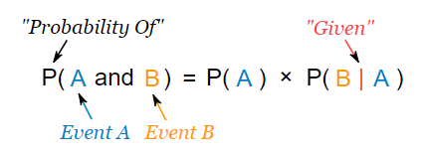

Learning Targets

I can determine and explain whether or not two events are independent.

**Independent Events**

We say **two events,** A and B, are **independent** if the following is true:

$P\left(B given A\right)=P(B)$ and likewise $P\left(A given B\right)=P(A)$

Interpret what the definition of **independent events** means in your own terms.

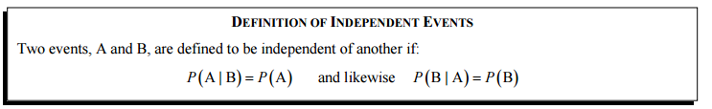

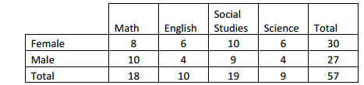Example 1: A survey or 57 sixth graders was done to determine which subject was their favorite. The results are shown in the table below sorted by gender:

1. Based on this data, are the events “the student is male” and “math is a favorite subject” independent of each other?
2. Does this data suggest that gender and a preference for Social Studies are independent of each other? Justify.

**Product Rule of Independence**

Given that $P\left(A | B\right)=\frac{P(A and B)}{P(B)}$, do the following:

a) If A and B are independent, then rewrite this formula and solve for $P(A and B).$

b) The probability that a person is left handed is 12%, the probability that they have brown eyes is 42%, and the probability that they have brown eyes and are left handed is 2%. Is the event of having brown eyes independent of being left handed? Support your answer.

**Practice**

Example 1:

|  |  |  |  |
| --- | --- | --- | --- |
|  | No Household  Member Smokes | At Least One Household Member Smokes | Total |
| **Student Has Asthma** | $$69$$ | $$113$$ | $$182$$ |
| **Student Does Not Have Asthma** | $$473$$ | $$282$$ | $$755$$ |
| **Total** | $$542$$ | $$395$$ | $$937$$ |

You are asked to determine if the two events “a randomly selected student has asthma” and “a randomly selected student has a household member who smokes” are independent. Show this using both conditional probability and the product rule of independence.

Example 2:

