Name _________________________________

Unit 3 Lesson 4 HW - Sine

Graph one cycle of each of the following:

1. 3.
2. 4.

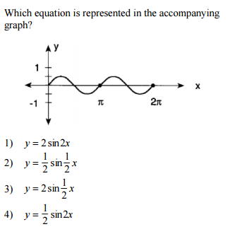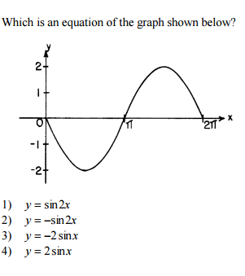5. 6.

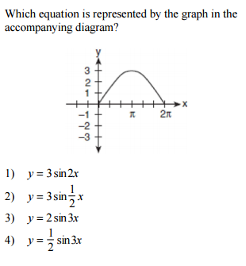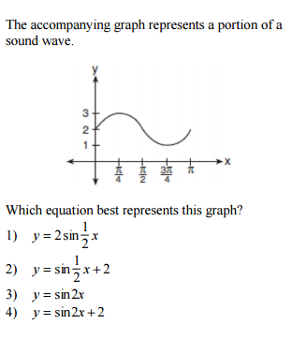

7. 8.