**REVIEW OF MODULE 3 NAME:__________________________________________**

**EXTENDED RESPONSE**

1. A thumbtack is stuck to a bicycle tire. If the tire has a radius of 22 cm, sketch the height of the thumbtack above the ground as the tire rotates counterclockwise through 4 turns. Start your graph when the thumbtack is at the 3 o’clock position. Provide appropriate labels on the graph.

Write the equation for the graph.

1. If a Ferris wheel with a diameter of 340 feet completes 3 turns and passengers board the Ferris wheel at the bottom (which is 4 feet above the ground), create a graph of a function that represents the height above the ground of the passenger car. Provide appropriate labels on the axes.
2. An oscilloscope is a machine that changes sound waves into electric impulses and shows their graph on a monitor. One such graph can be represented by the equation $A\left(t\right)=12sin⁡(\frac{2π}{15 }t)$ where $t$ represents time in seconds. What is the period of the function?
3. What is the maximum value of the function: $f\left(x\right)=12-3\cos\left(\frac{3π}{2}x\right)?$
4. Using the domain of $0≤x≤2π$, graph the functions $y=sinx$ and $y=cosx$ on the same

set of axes below.

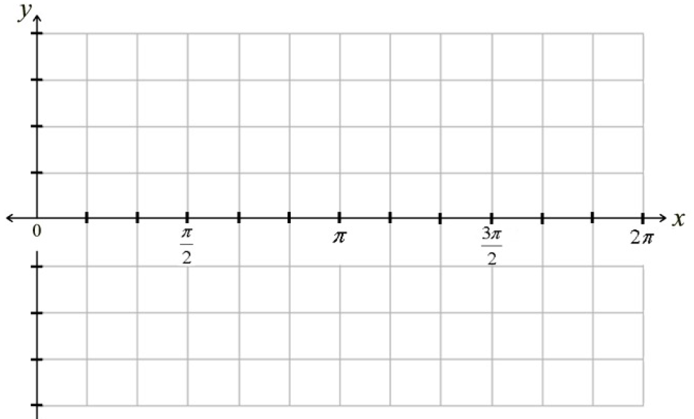

1. For what values of $x$ does $sinx=cosx ?$?
2. In what interval(s) are both $y=sinx$ and $y=cosx$ positive?
3. In what interval(s) are both $y=sinx$ and $y=cosx$ negative?
4. Graph $y=tanx$ on the set of axes below:



1. Complete the chart below based upon the graphs of $y=tanx$ and $y=sinx$.

|  |  |
| --- | --- |
| Similarities | Differences |
|  |  |

1. Write an equation for each of the functions shown below:

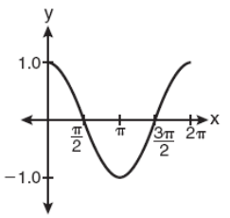 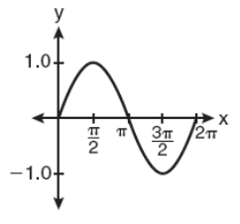 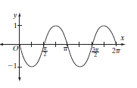

_______________________ ________________________ ____________________________

1. Complete the chart below:

|  |  |  |  |  |  |  |  |  |
| --- | --- | --- | --- | --- | --- | --- | --- | --- |
| $$θ$$ | $$0^{0}$$ | $${30}^{0}$$ | $${45}^{0}$$ | $${60}^{0}$$ | $${90}^{0}$$ | $${180}^{0}$$ | $${270}^{0}$$ | $${360}^{0}$$ |
| $$sinθ$$ |  |  |  |  |  |  |  |  |
| $$cosθ$$ |  |  |  |  |  |  |  |  |
| $$tanθ$$ |  |  |  |  |  |  |  |  |

1. Convert each of the degree measures below to radian measure.

|  |  |  |  |
| --- | --- | --- | --- |
| $${330}^{0}$$ |  | $${270}^{0}$$ |  |
| $${225}^{0}$$ |  | $${150}^{0}$$ |  |
| $${90}^{0}$$ |  | $${315}^{0}$$ |  |

1. Convert each of the radian measures below to degree measure.

|  |  |  |  |
| --- | --- | --- | --- |
| $$\frac{5π}{6}$$ |  | $$\frac{11π}{6}$$ |  |
| $$\frac{2π}{3}$$ |  | $$\frac{3π}{4}$$ |  |
| $$\frac{π}{3}$$ |  | $$\frac{8π}{9}$$ |  |

1. State the **amplitude**, **period**, **horizontal shift**, and **vertical shift** for each of the following:
2. $y=4\sin\left(2x+π\right)-1$ b) $y=-5\cos{(6x-\frac{π}{7}})+2$
3. Suppose a windshield wiper arm has a length of 22 inches and rotates through an angle of ${110}^{0}$.

What distance does the tip of the wiper travel, *to the nearest inch*, as it moves from one side of the windshield to the other.

1. Verify the Pythagorean identity: $1+\tan^{2}x=\sec^{2}x$
2. Verify this identity: $secθ-sinθtanθ=cosθ$
3. Given that $\sin^{2}x+\cos^{2}x=1$, and $cosx=\frac{-3}{4}$, find the value of $sinx$
4. Write the equation of a graph satisfying all of the following conditions:

* Sine
* Period of $9π$
* Amplitude of 7
* Shifted 3 down

_________________________________________________________________

1. Graph ONE cycle of: $y=2\cos\left(\frac{1}{2}x-π\right)$
2. Graph ONE cycle of: $y=-4sin⁡(3x+π$)
3. Graph ONE cycle of: $y=-3cos⁡(6x+π)$