New Password functionality in ParentCONNECTxp.

There is a new password reset functionality that requires a users to answer a security question at login, even for existing accounts at the first time of login. This will allow you to have your login information emailed to you if you forget your password.

1. When you log in to ParentCONNECTxp, you will be prompted to answer a security question in the following window. There are 3 questions you can choose from.
2. Select the question you wish to answer and type the answer in the space provided, then click apply.
3. You will then be able to log in to ParentCONNECT xp.

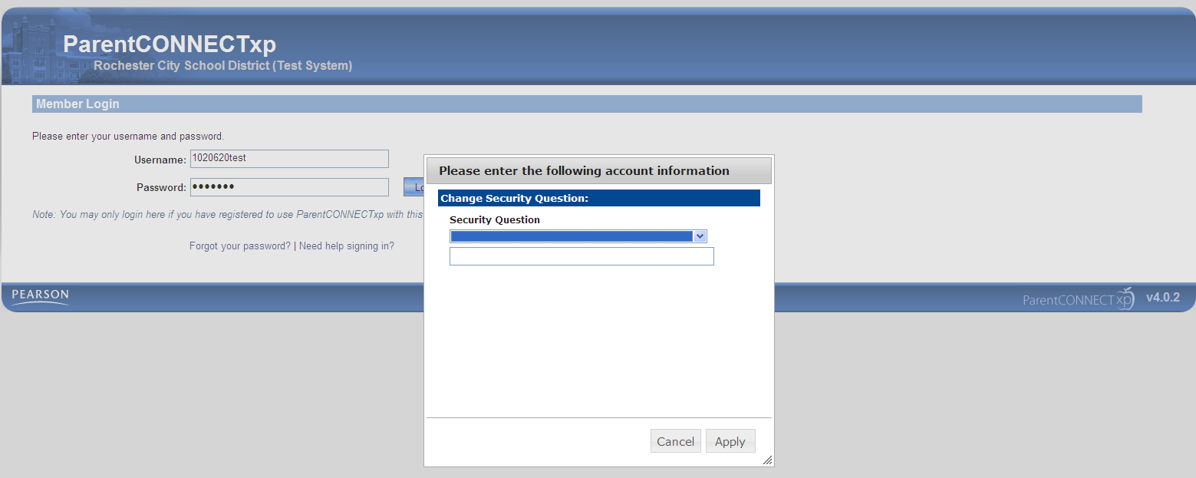

If you forget your password, follow the steps below.

1. Click on the link “Forgot your Password” on the login screen.
2. Enter your username. (This is sent to you 5 days after you submit your request).
3. Click “Next”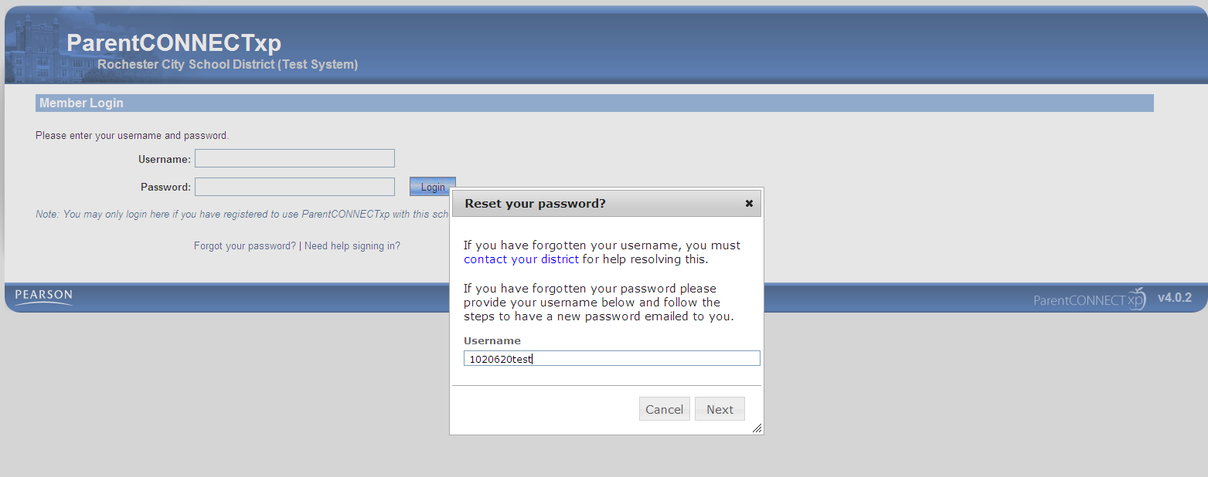
4. Answer the security question with the information you supplied your first time logging in.

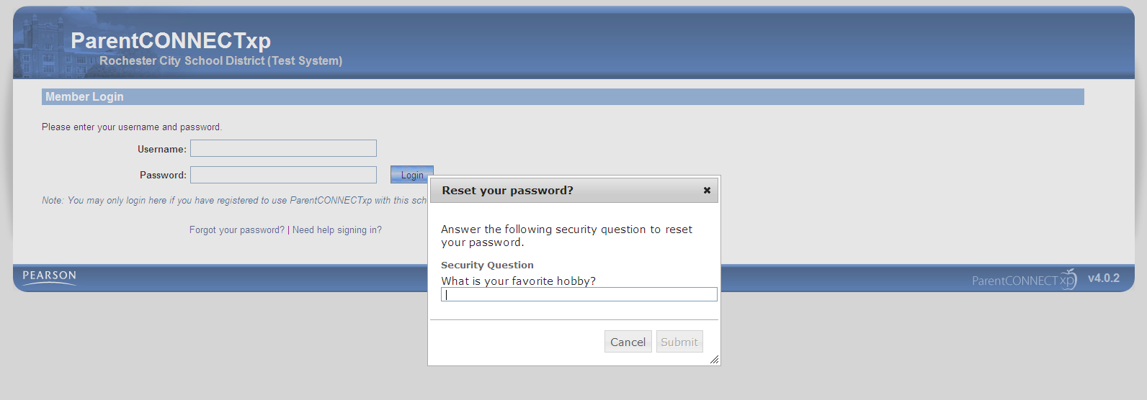

1. You will receive a notification that your new password has been emailed to you.

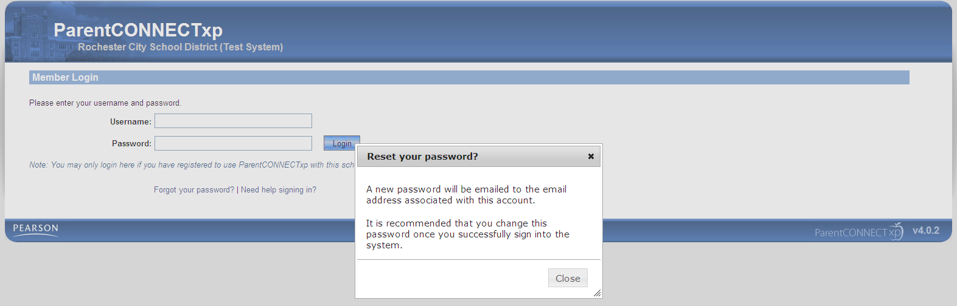

You reset your password or change your security question at any time by clicking “Settings”.