You can add students to your ParentCONNECTxp account by following these steps

Once you are logged into ParentCONNECTxp,

1. Click on the Settings link at the top right.

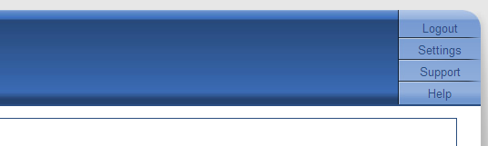

1. Scroll down to the student assignments section
2. Complete the information
3. Click “Add to List” button. NOTE: This must be clicked after each student
4. When finished, click the Submit button

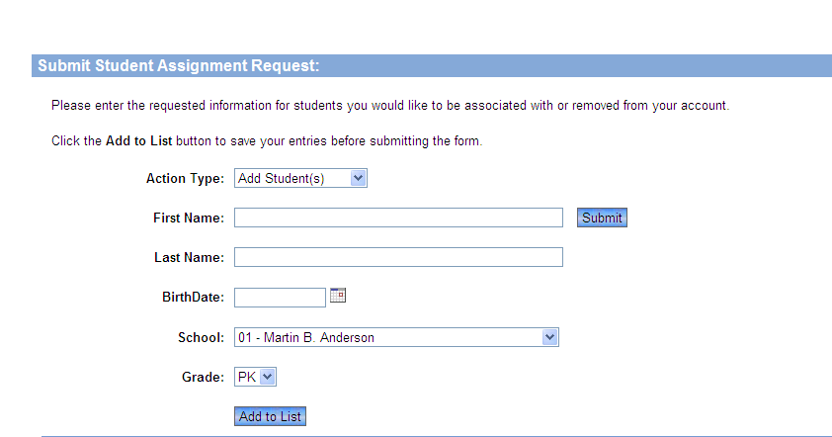

2

4

3

5

Your students will be attached once the process is completed.